**Jaishree S 231901011**

**EXERCISE 1C WINDOWS FUNDAMENTALS 3**

**AIM**:

To understand and utilize built-in Microsoft security tools such as Windows Updates, Windows Security, and BitLocker to enhance the security and integrity of a Windows system.

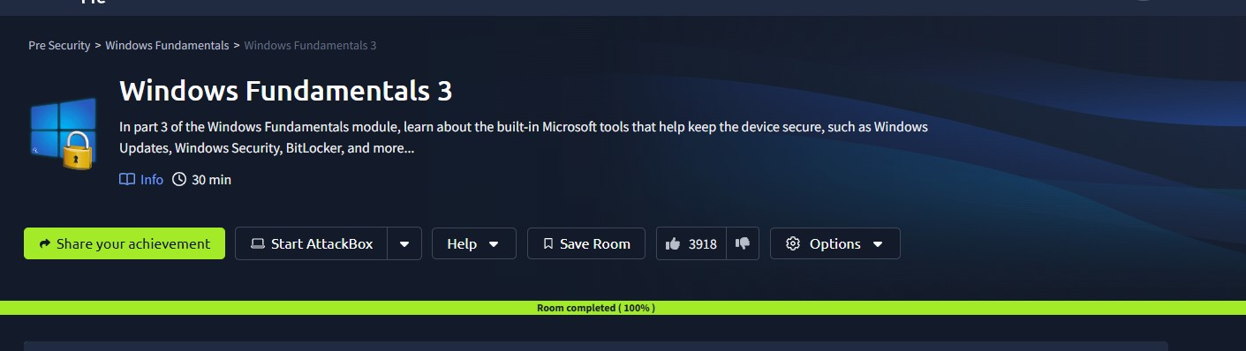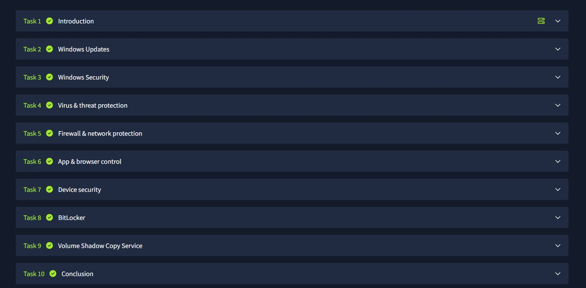

**RESULT**:

Successfully learned how to configure and manage Windows security features, ensuring system protection through updates, antivirus measures, and encryption mechanisms.